**Title**

End-to-End Jenkins Setup with User Management, Role-Based Access Control, Node Configuration, and Private GitHub Repository Integration

**Objective**

* To install and configure Jenkins on an EC2 instance
* To secure Jenkins using role-based access control
* To create multiple users with limited permissions
* To configure Jenkins built-in node and executors
* To create Jenkins jobs and integrate GitHub repositories
* To connect and build a **private GitHub repository** using Personal Access Tokens (PAT)
* To identify, troubleshoot, and fix common Jenkins build errors

**Prerequisites**

* AWS EC2 instance running Amazon Linux
* Jenkins installed and running on port 8080
* Admin access to Jenkins
* GitHub account with at least one repository
* Internet access from Jenkins server
* Git installed on Jenkins server
* Basic knowledge of Jenkins UI and GitHub

**Errors Faced and How They Were Fixed**

**Error 1: Access Denied – Missing Overall/Read Permission**

**Error Message:**

Devops is missing the Overall/Read permission

**Cause:**

* Role-Based Authorization Strategy enabled
* Users created but **no global roles or permissions assigned**

**Fix:**

* Installed **Role-Based Authorization Strategy** plugin
* Created **Global Roles** (admin, devops, testing)
* Assigned mandatory permission:
  + Overall → Read
* Mapped users to respective roles

**Error 2: Git Command Not Found**

**Error Message:**

git: command not found

**Cause:**

* Git was not installed on the Jenkins EC2 server

**Fix:**

* Installed Git using:

yum install git -y

**Error 3: Authentication Failed for Private GitHub Repository**

**Error Message:**

Invalid username or token.

Password authentication is not supported for Git operations.

**Cause:**

* GitHub no longer supports password authentication for HTTPS
* Jenkins attempted to clone a **private repository** without a token

**Fix:**

* Generated **GitHub Personal Access Token (classic)**
* Selected scope:
  + repo
* Added credentials in Jenkins as:
  + Username: GitHub username
  + Password: GitHub PAT
* Selected the credential in job configuration

**Error 4: Couldn't Find Any Revision to Build**

**Error Message:**

ERROR: Couldn't find any revision to build.

**Cause:**

* Jenkins default branch configuration did not match repository branch
* GitHub repository used main branch

**Fix:**

* Updated Jenkins job configuration:

Branches to build → */main

**Conclusion**

* Jenkins was successfully installed and secured
* Role-Based Access Control implemented correctly
* Multiple users (Admin, DevOps, Testing) created with proper permissions
* Jenkins built-in node configured with executors and labels
* Git installed and verified on the server
* Jenkins jobs created and executed successfully
* Private GitHub repository integrated securely using PAT
* Build failures analyzed, fixed, and validated with successful builds

Install Jenkins and run Jenkins on port number 8081.

**1. Launched an EC2 Instance**

* Opened **EC2 → Launch instance**
* Set instance **Name** as jenkins
* Selected **Amazon Linux 2023 AMI**
* Chose instance type (t3.micro / free-tier)
* Allowed required ports in Security Group:
  + SSH (22)
  + Jenkins (8080)
  + Custom tcp (8081)
* Launched the instance successfully

**2. Connected to EC2 Instance**

* Connected via SSH as root / ec2-user
* Navigated to /opt directory

**3. Added Jenkins YUM Repository**

* Downloaded Jenkins repo file into YUM repositories
* wget -O /etc/yum.repos.d/jenkins.repo https://pkg.jenkins.io/redhat/jenkins.repo
* Verified repo connectivity and keys

**4. Updated System Packages**

* Performed full system update using YUM

**5. Installed Java (Jenkins Dependency)**

* Attempted OpenJDK installation
* yum install java-17-amazon-corretto -y
* Installed **Amazon Corretto Java 17** successfully

**6. Installed Jenkins**

* Installed Jenkins package from official repo
* yum install jenkins -y
* Jenkins package downloaded and installed successfully

**7. Enabled and Started Jenkins Service**

* Enabled Jenkins to start on boot
* Started Jenkins service
* Verified Jenkins service status (running)

**8. Verified Jenkins Service Files**

* Navigated to /usr/lib/systemd/system
* Verified jenkins.service file exists
* Changed the port to 8081

**9. Restarted Jenkins After Configuration Check**

* Reloaded systemd daemon
* Restarted Jenkins service
* Checked Jenkins logs and status

**10. Accessed Jenkins Web UI**

* Opened browser
* Accessed Jenkins using:
* http://<EC2-Public-IP>:8081
* Jenkins **Unlock** screen displayed

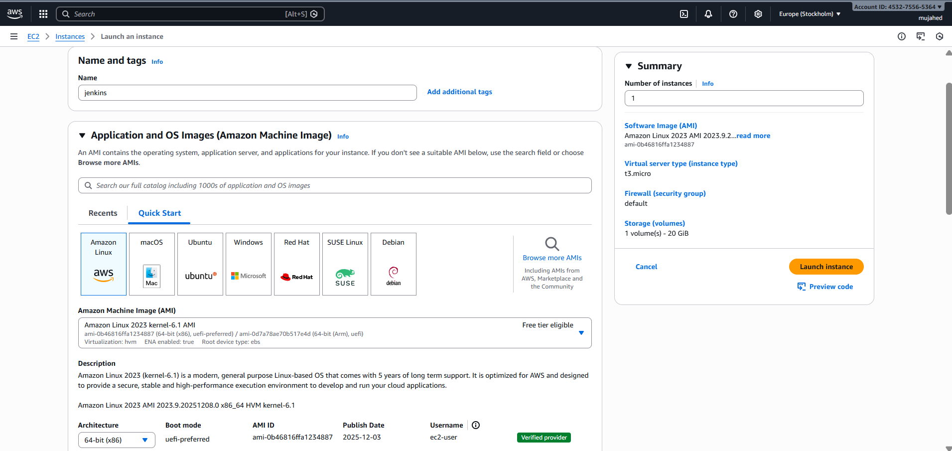

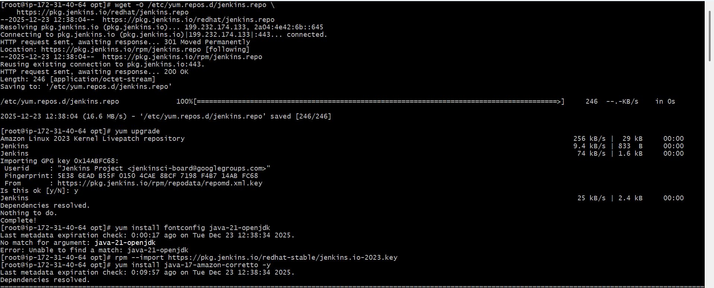

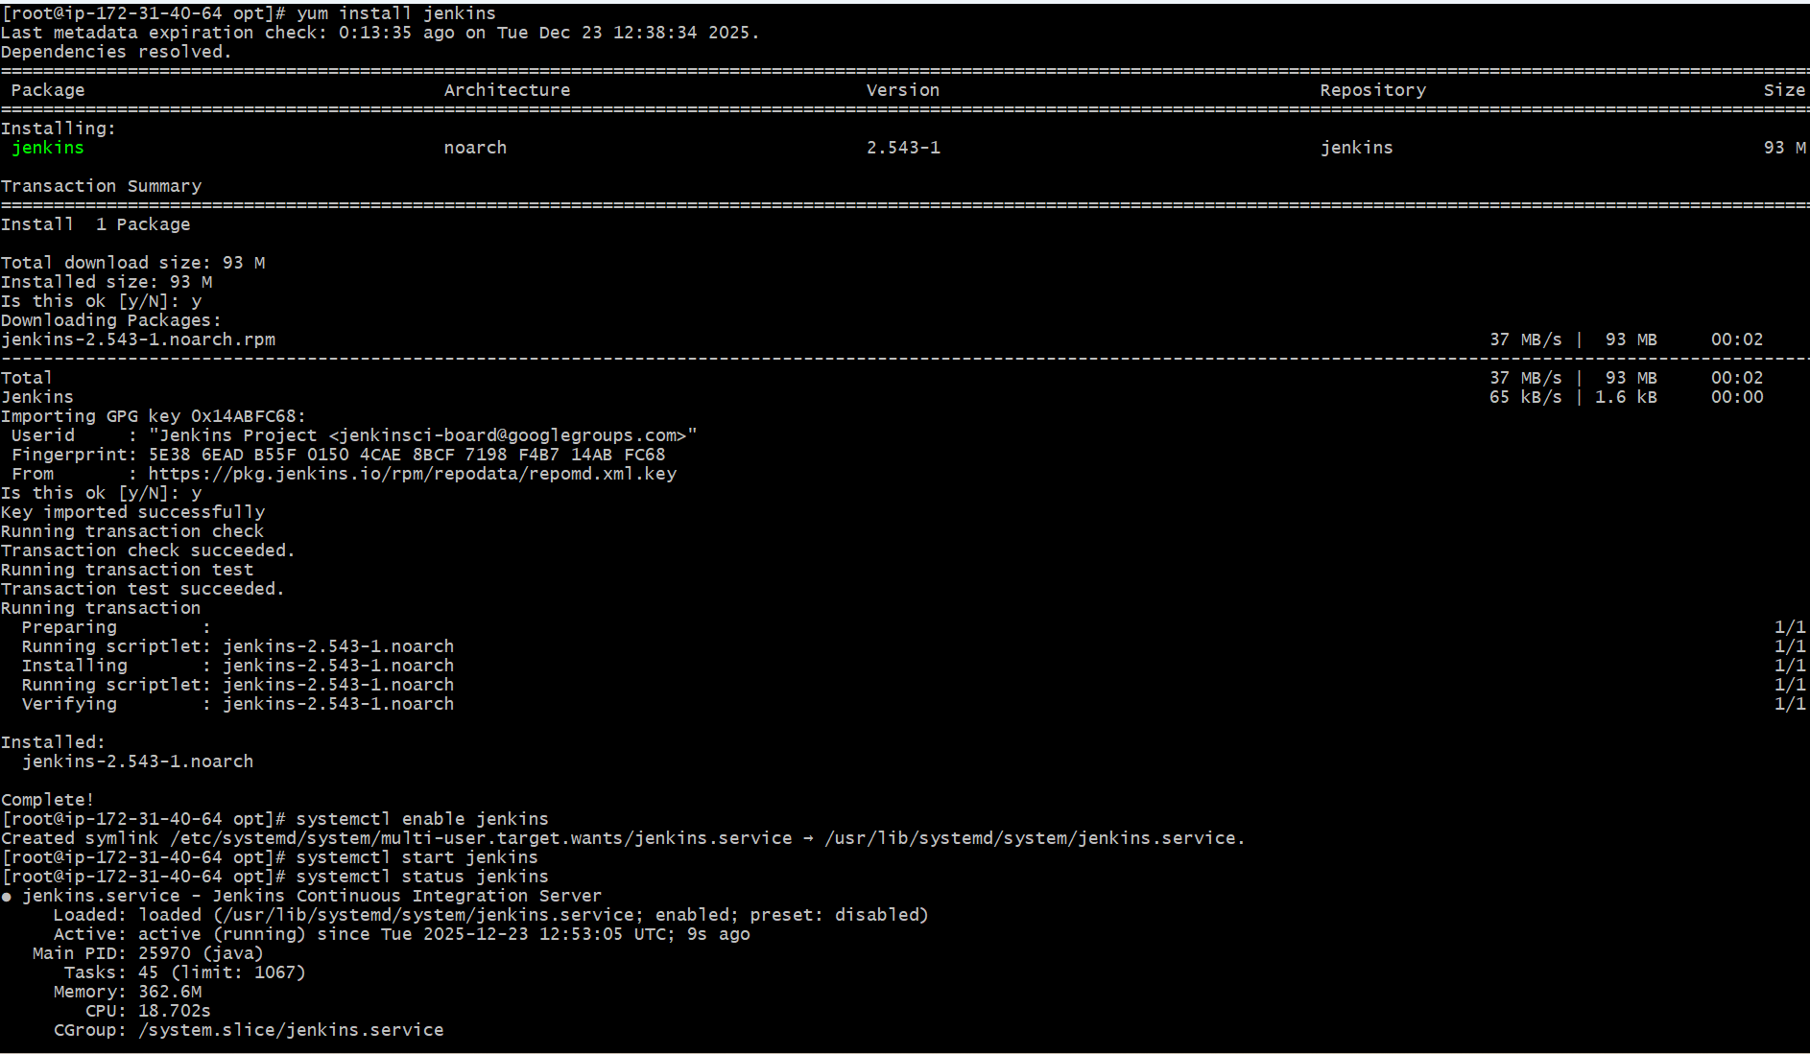

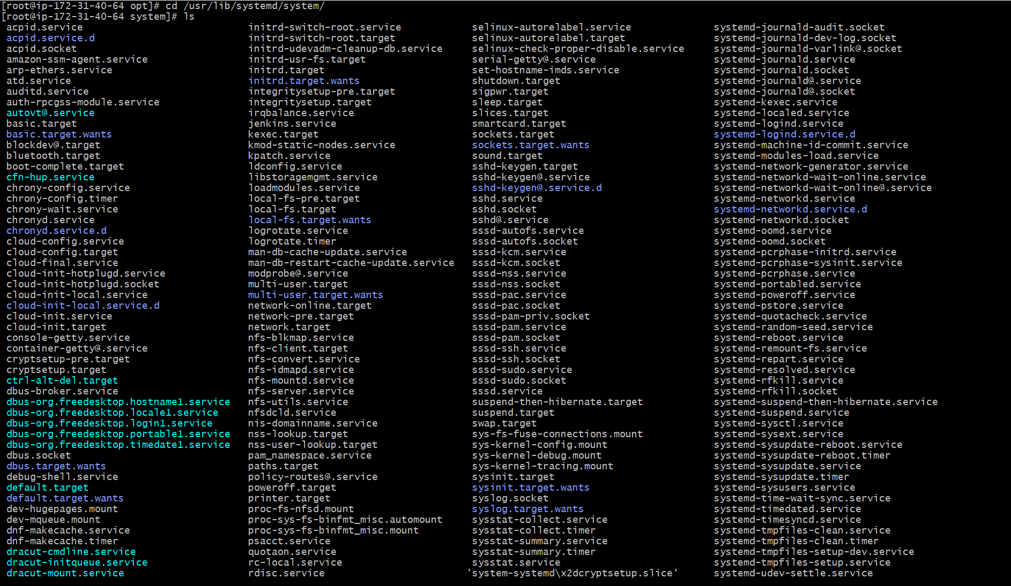

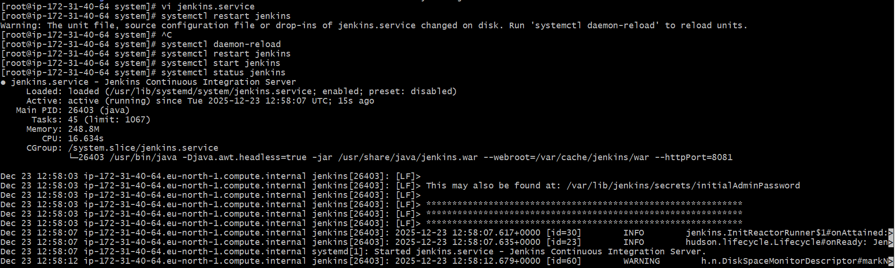

Secure Jenkins server

**1. Accessed Jenkins Web Interface**

* Opened browser
* Entered Jenkins URL using public IP and port **8081**

http://13.53.146.172:8081

* Jenkins **Unlock Jenkins** screen appeared

**2. Identified Initial Admin Password Location**

* Jenkins UI displayed the password file path:

/var/lib/jenkins/secrets/initialAdminPassword

**3. Retrieved Initial Admin Password from Server**

* Logged into EC2 instance as root
* Displayed the initial admin password using terminal

**Command used:**

cat /var/lib/jenkins/secrets/initialAdminPassword

* Copied the generated password

**4. Unlocked Jenkins**

* Pasted the copied password into **Administrator password** field
* Clicked **Continue**
* Jenkins successfully unlocked

**5. Installed Recommended Plugins**

* Jenkins redirected to **Getting Started**
* Selected **Install suggested plugins**
* Jenkins installed default plugins:
  + Pipeline
  + Git
  + Credentials
  + Folders
  + Workspace Cleanup
  + OWASP Markup Formatter
  + Build Timeout
  + GitHub Branch Source
  + Matrix Authorization Strategy
  + SSH Build Agents
  + Email Extension
  + And other required dependencies

**6. Logged in as Admin User**

* Jenkins completed setup
* Redirected to Jenkins dashboard
* Default admin user was created

**7. Opened Admin Security Settings**

* Clicked **admin** (top-right)
* Navigated to:

admin → Security

**8. Set New Admin Password**

* Entered new password in **Password** field
* Re-entered password in **Confirm Password**
* Clicked **Save / Apply**

**9. Logged Out and Verified New Password**

* Logged out of Jenkins
* Jenkins redirected to login page

**10. Logged In with New Credentials**

* Entered:
  + **Username:** admin
  + **Password:** (newly set password)
* Clicked **Sign in**
* Login successful

**11. Verified Jenkins Secrets Directory (Cleanup Step)**

* Navigated to Jenkins secrets directory
* Listed files
* Removed initial admin password file (optional security cleanup)

**Commands used:**

cd /var/lib/jenkins/secrets

ls

rm initialAdminPassword

ls

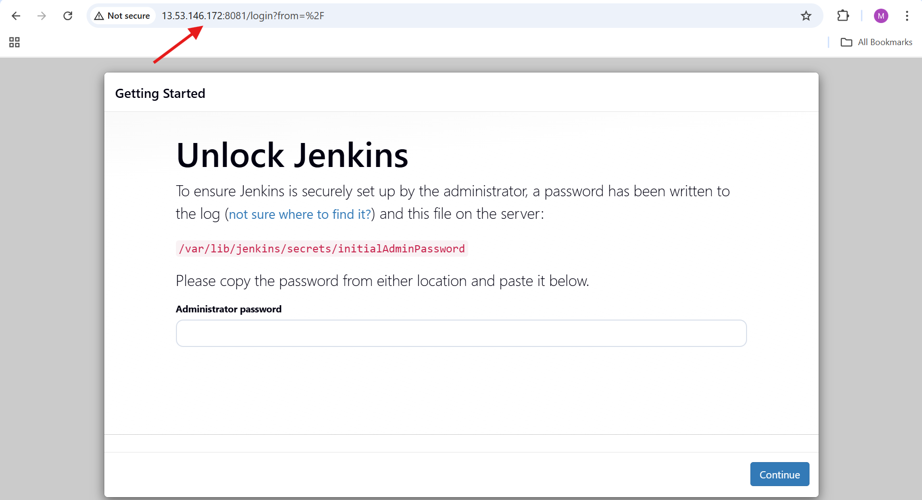

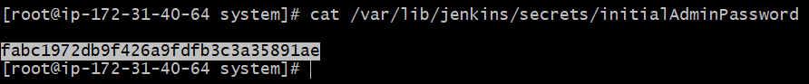

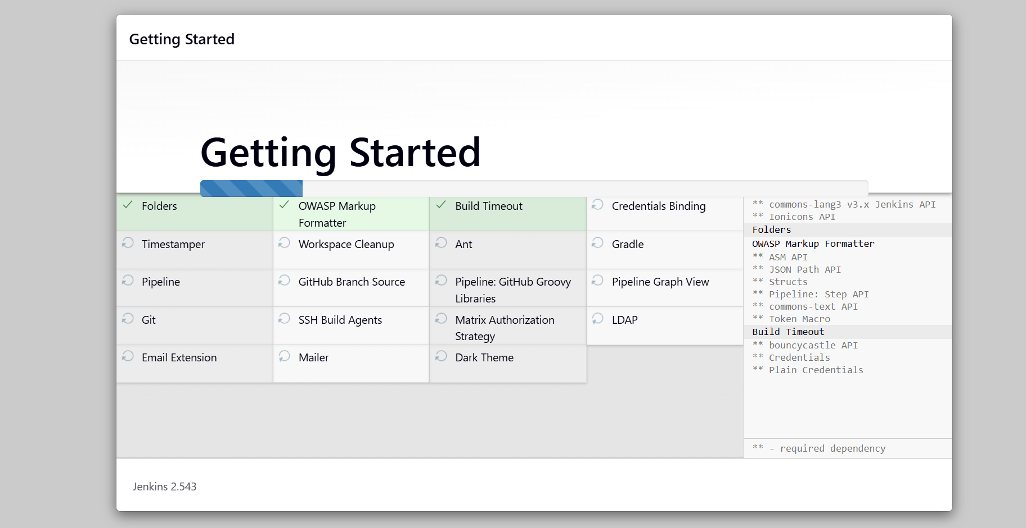

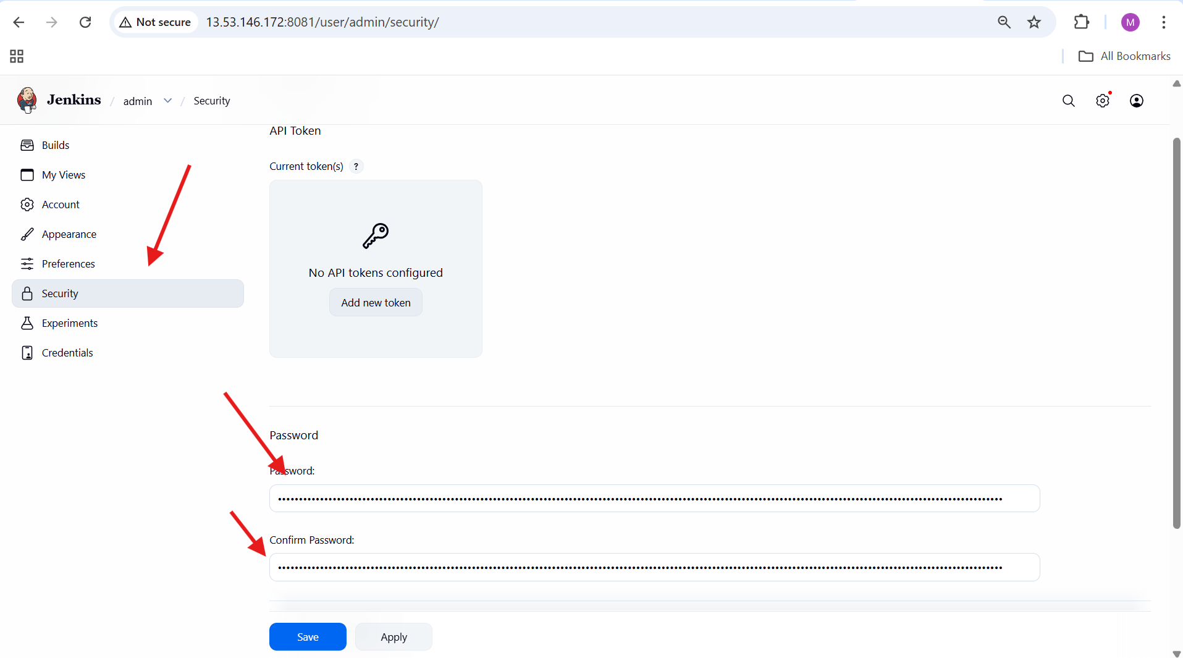

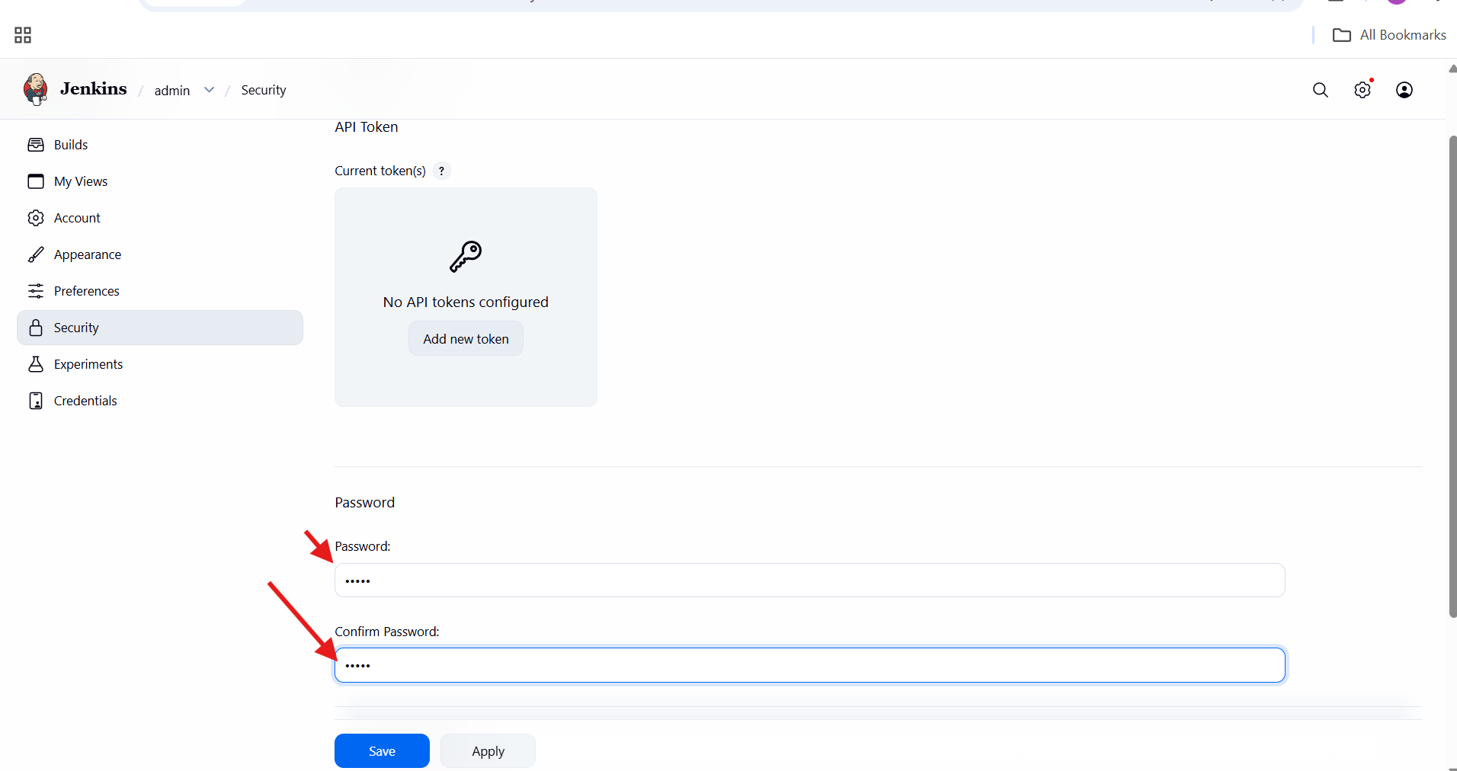

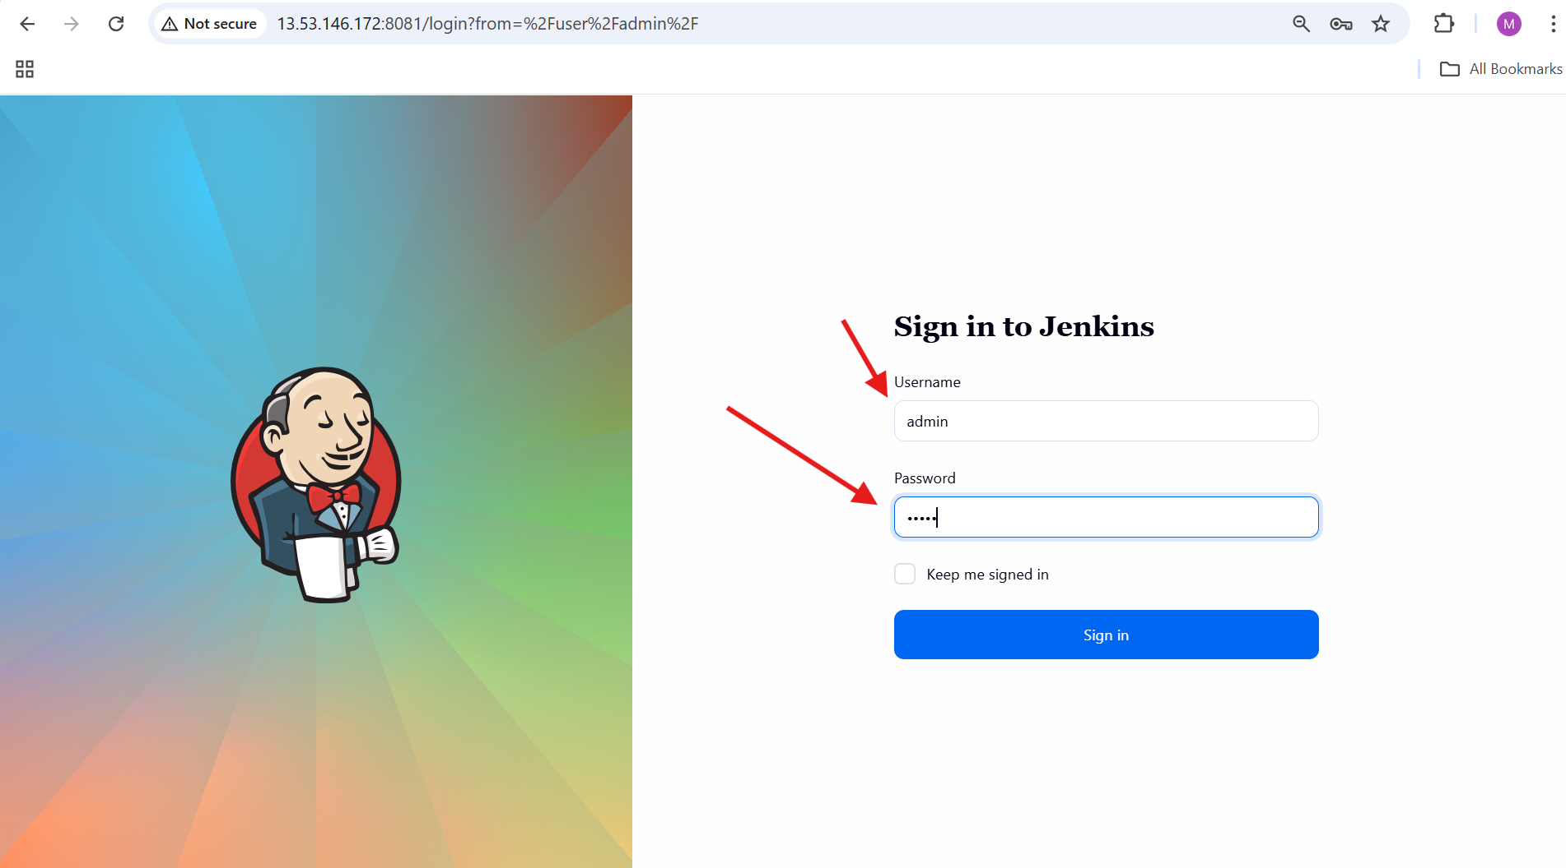

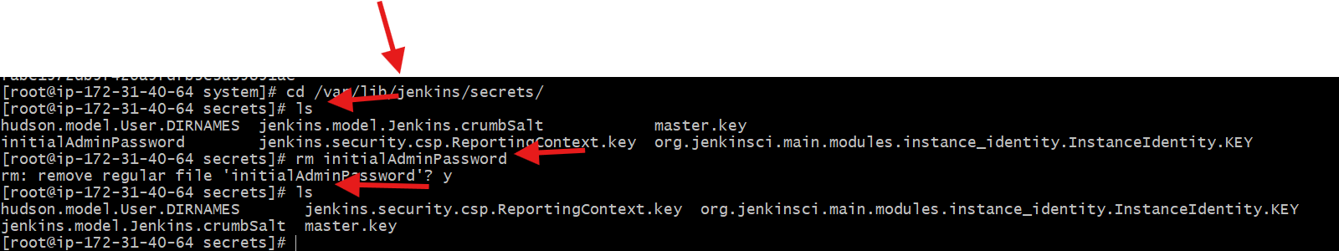

Create users called DevOps, Testing in Jenkins with Limited access.

**1. Opened Jenkins Manage Page**

* Logged in as **admin**
* Navigated to:

Dashboard → Manage Jenkins

**2. Opened Users Management**

* Clicked **Users**
* Path:

Manage Jenkins → Users

**3. Created DevOps User**

* Clicked **Create User**
* Entered details:
  + Username: Devops
  + Full Name: Techie Devops
  + Email: devops509@gmail.com
  + Password & Confirm Password
* Clicked **Create User**

User Devops created successfully

**4. Created Testing User**

* Again clicked **Create User**
* Entered details:
  + Username: Testing
  + Full Name: Testing
  + Password & Confirm Password
* Clicked **Create User**

Users list now contains:

* admin
* Devops
* Testing

**5. Installed Role-Based Authorization Strategy Plugin**

* Navigated to:

Manage Jenkins → Plugins → Available plugins

* Searched for: role
* Selected:
  + **Role-based Authorization Strategy**
* Clicked **Install**

Plugin installed successfully

**6. Configured Jenkins Security Settings**

* Navigated to:

Manage Jenkins → Security

* Applied following settings:
  + **Security Realm**: Jenkins’ own user database
  + Disabled “Allow users to sign up”
  + **Authorization**: Role-Based Strategy
  + **Markup Formatter**: Plain text
* Clicked **Save**

**7. Disabled Inbound Agent Port (Security Hardening)**

* In **Security** page:
  + TCP port for inbound agents → **Disable**
  + CSRF Protection → Default Crumb Issuer
* Clicked **Save**

**8. Opened Role Management**

* Navigated to:

Manage Jenkins → Manage and Assign Roles

**9. Logged in as Devops User**

* Logged out from admin
* Opened Jenkins login page
* Logged in with:
  + Username: Devops
  + Password: ******

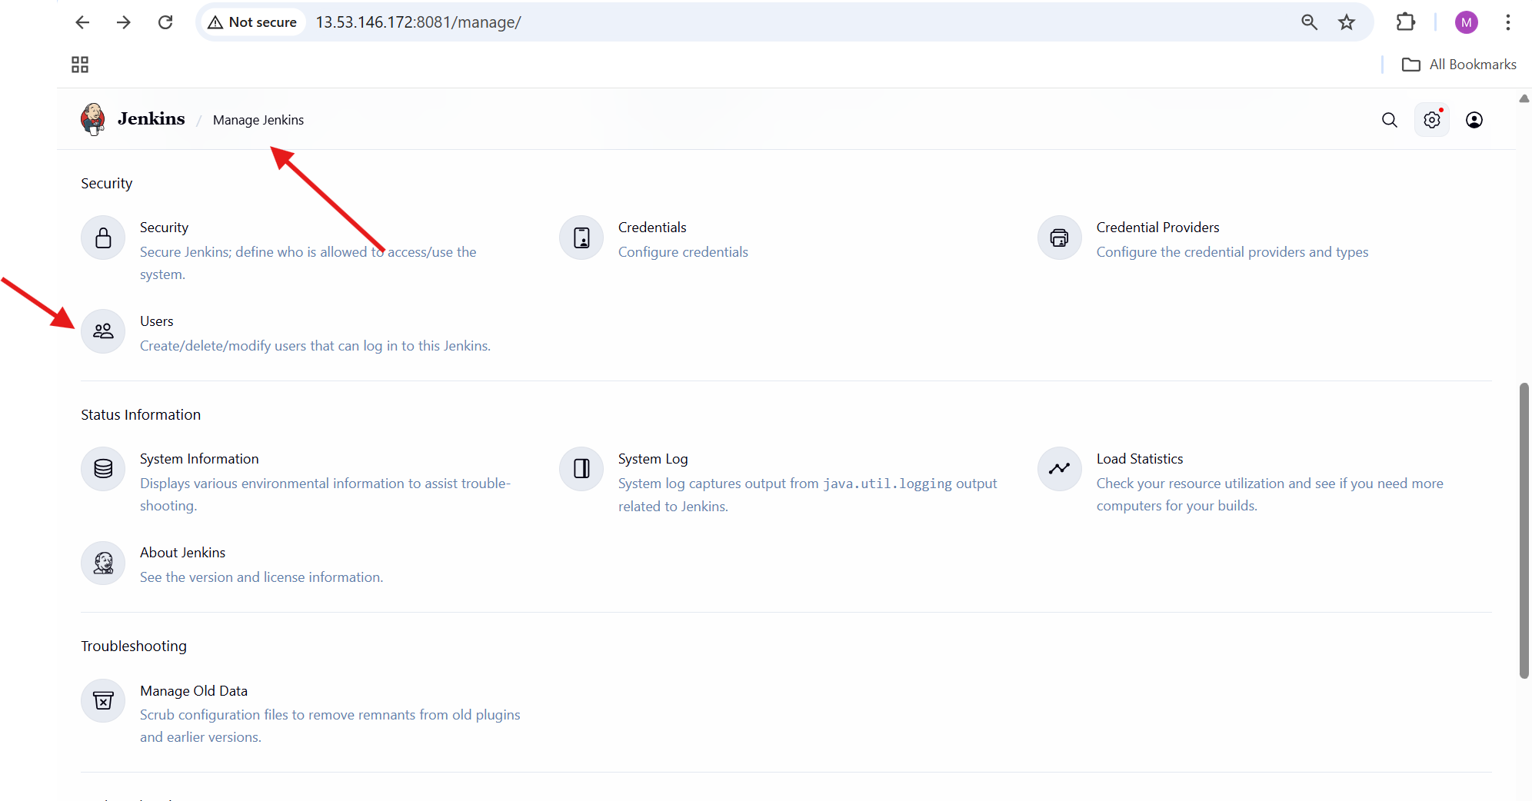

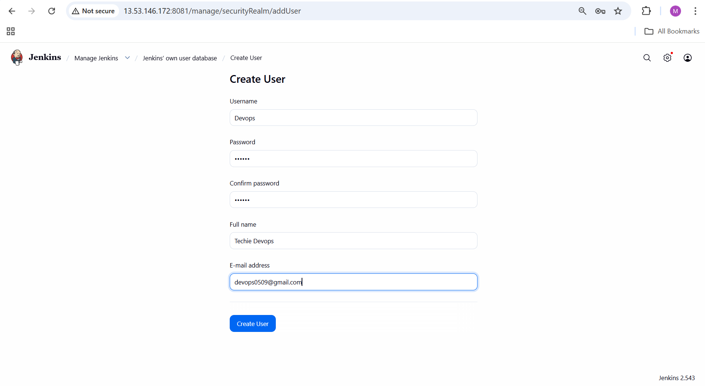

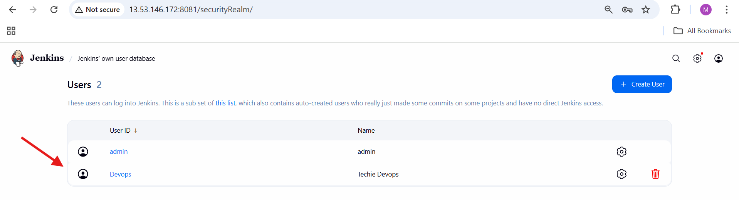

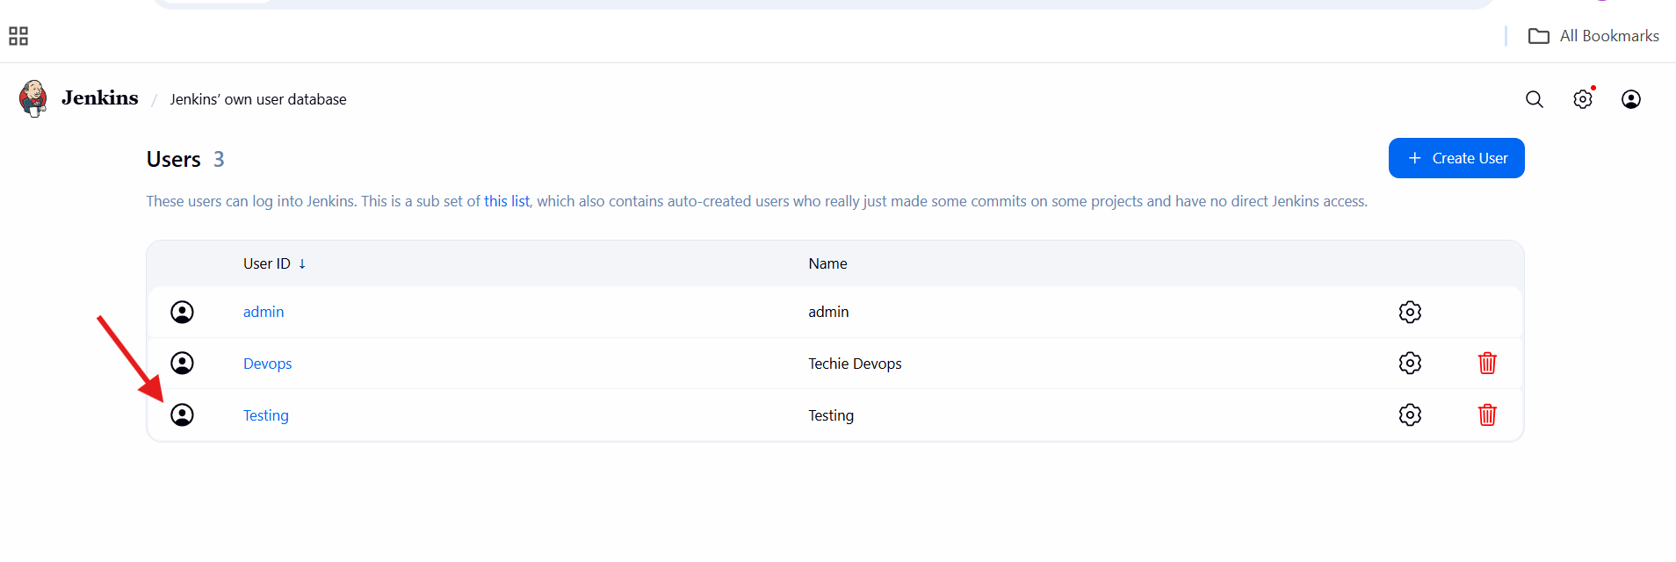

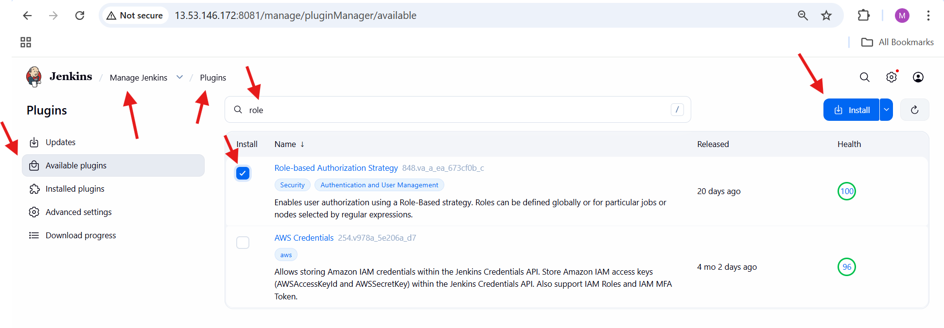

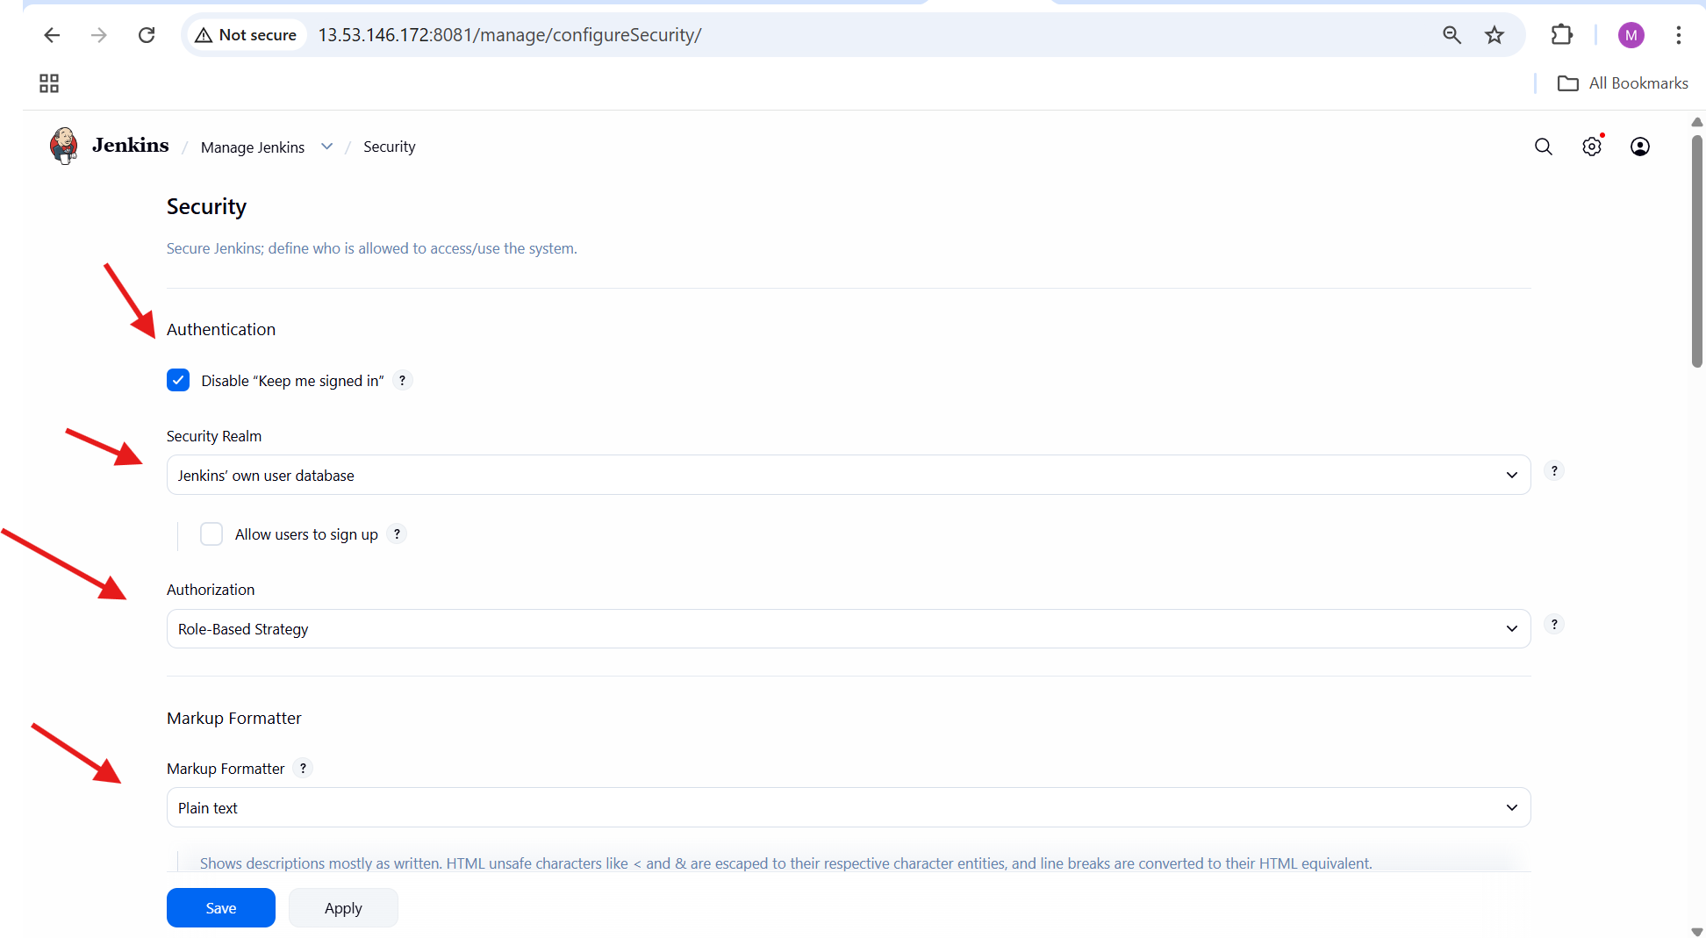

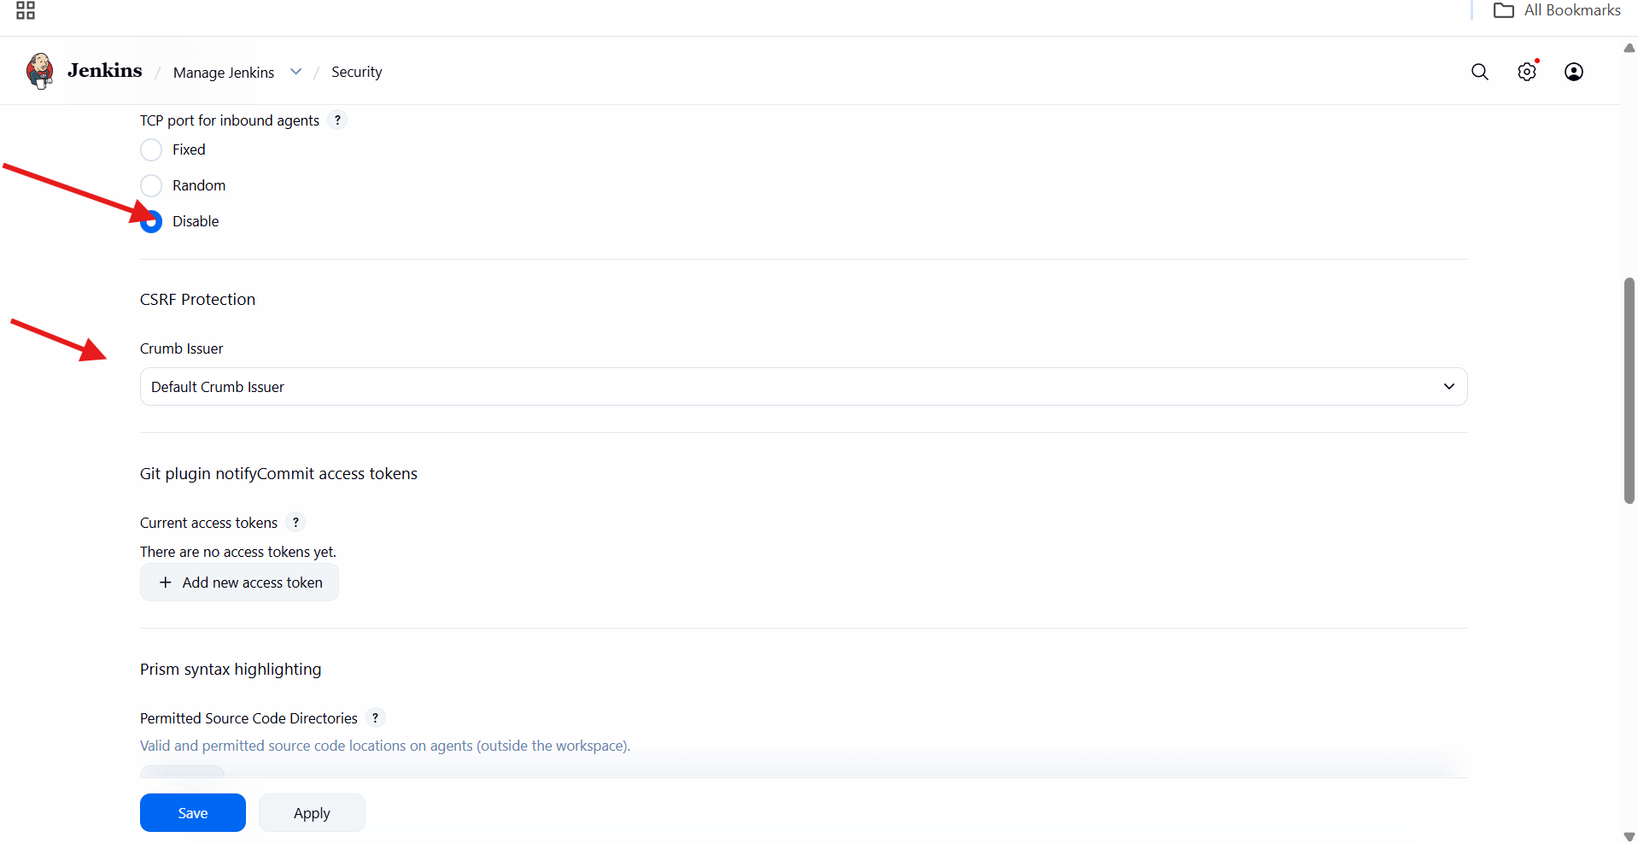

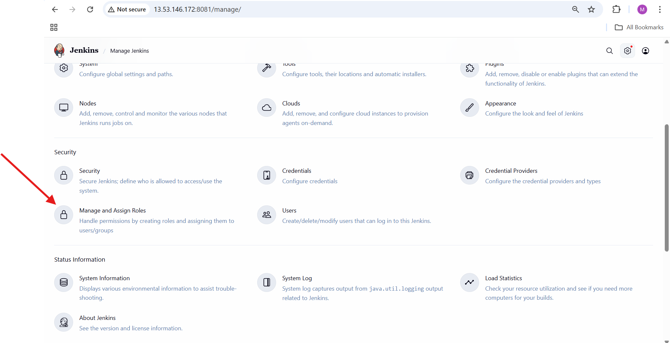

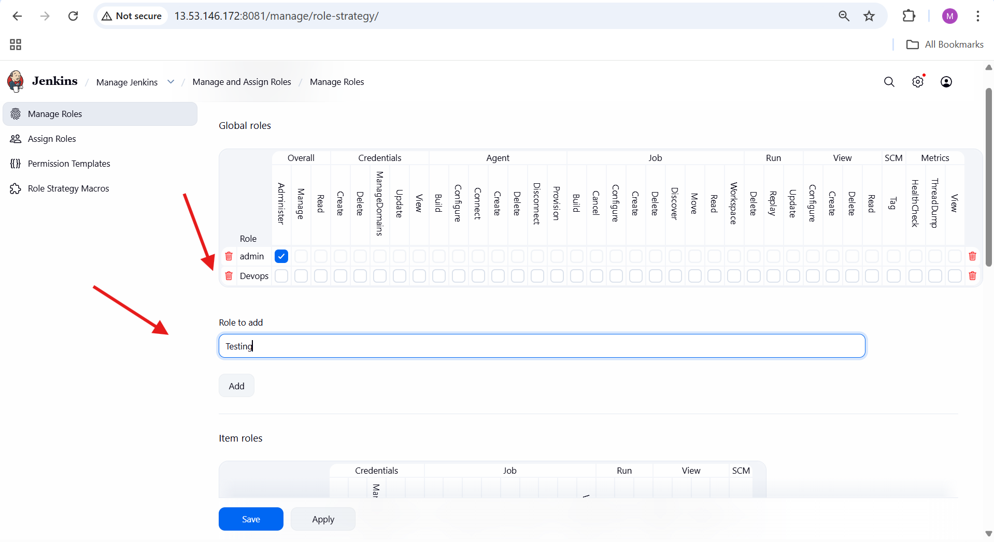

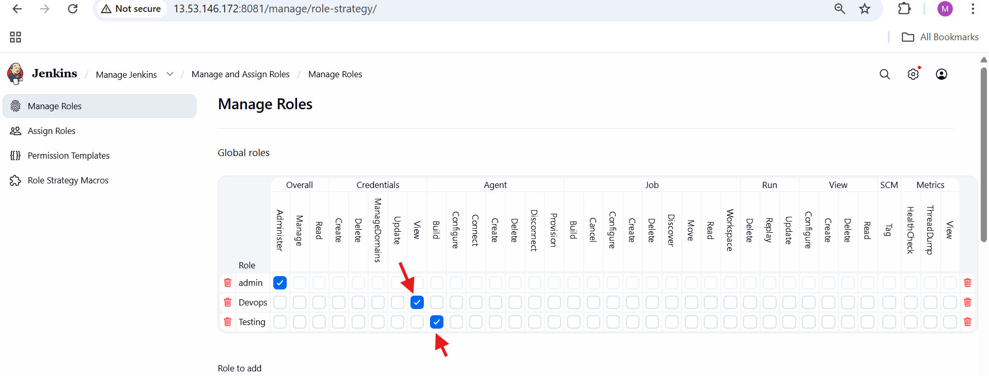

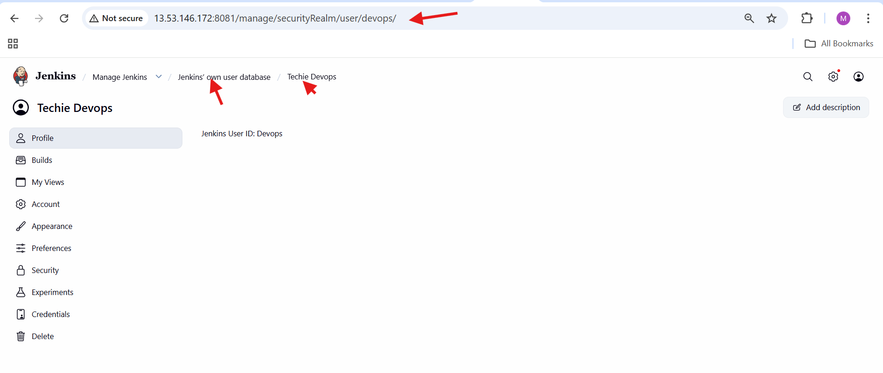

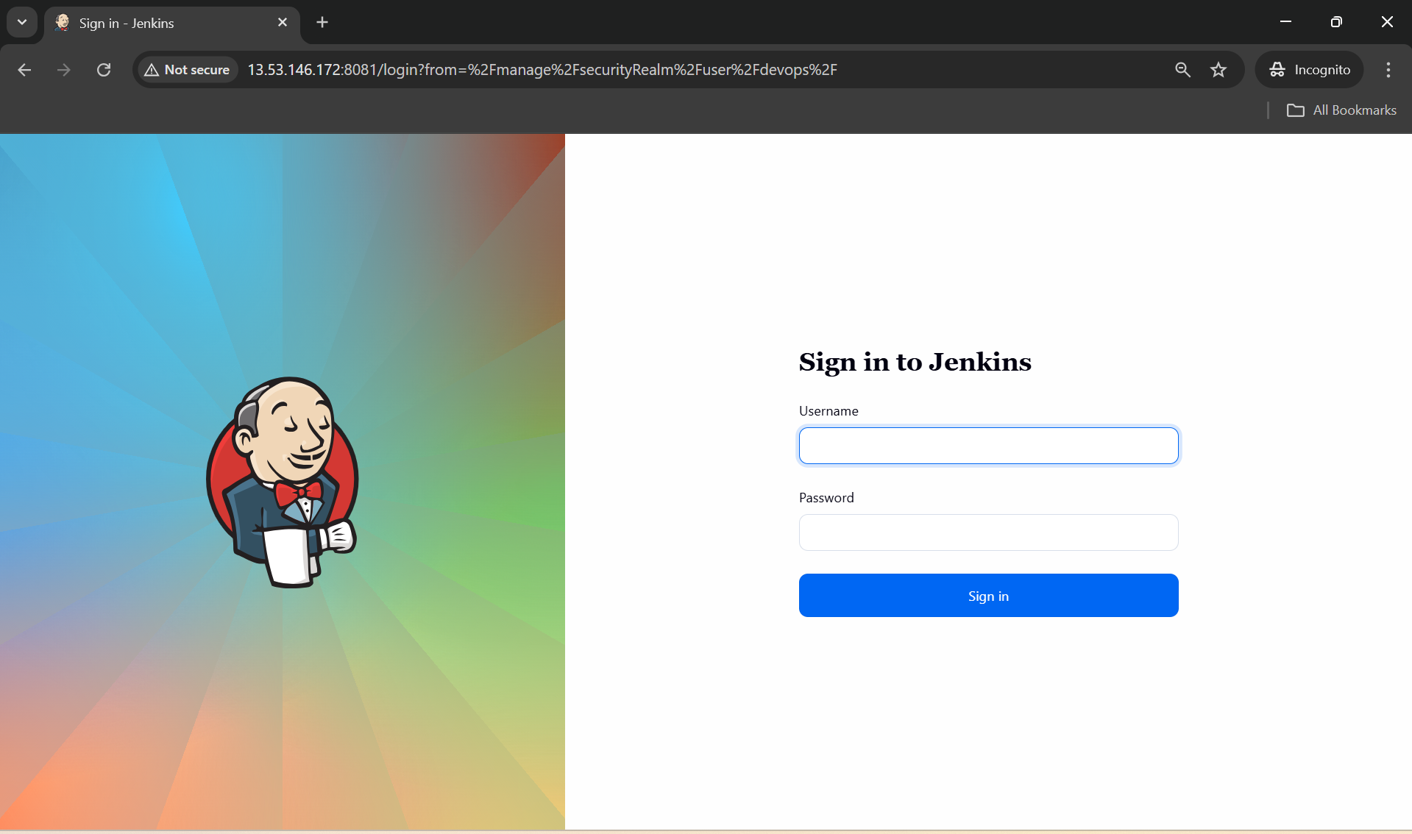

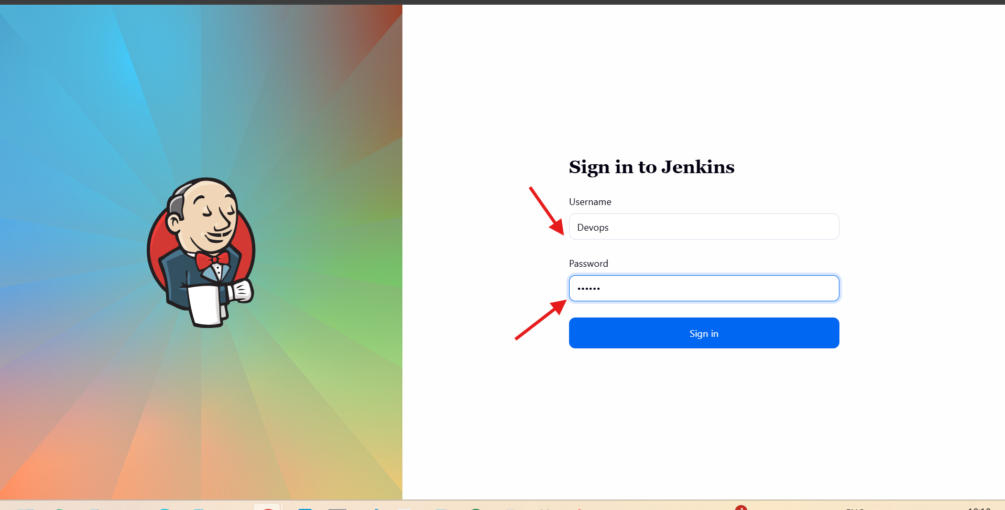

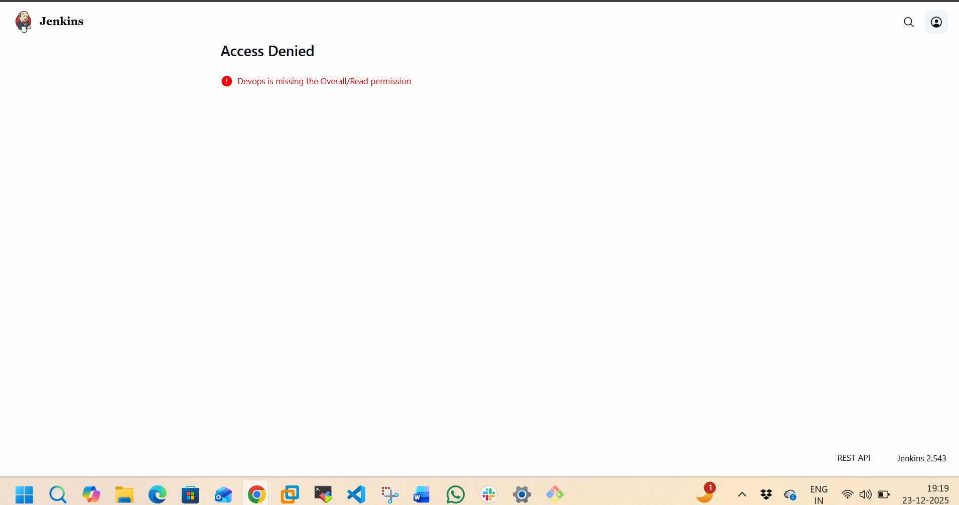

Configure labels and restrict the jobs to execute based on label only.

**1. Opened Built-In Node**

* Logged in to Jenkins as **admin**
* Navigated to:

Dashboard → Manage Jenkins → Nodes

* Clicked **Built-In Node**

**2. Opened Configure Page**

* Clicked **Configure** from left panel of Built-In Node

**3. Configured Executors**

* Set **Number of executors** to:

3

**4. Configured Node Label**

* Added label:

master

* Purpose: Allow jobs to run using label selector

**5. Enabled Label Restriction**

* Enabled:

Only build jobs with label expressions matching this node

**6. Enabled Disk Space Monitoring**

* Checked:

Disk Space Monitoring Thresholds

**7. Set Disk Space Threshold Values**

* Free Disk Space Threshold:

1GB

* Free Disk Space Warning Threshold:

2GB

* Free Temp Space Threshold:

0.1GB

* Free Temp Space Warning Threshold:

2GB

**8. Saved Node Configuration**

* Clicked **Save** (or **Apply**)

**9. Verified Node Status**

* Returned to **Built-In Node → Status**
* Confirmed:
  + Label shows as master
  + Node online
  + Executor status visible

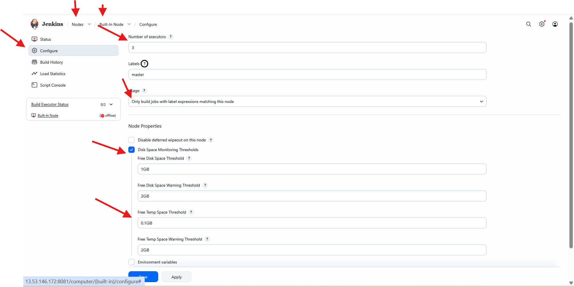

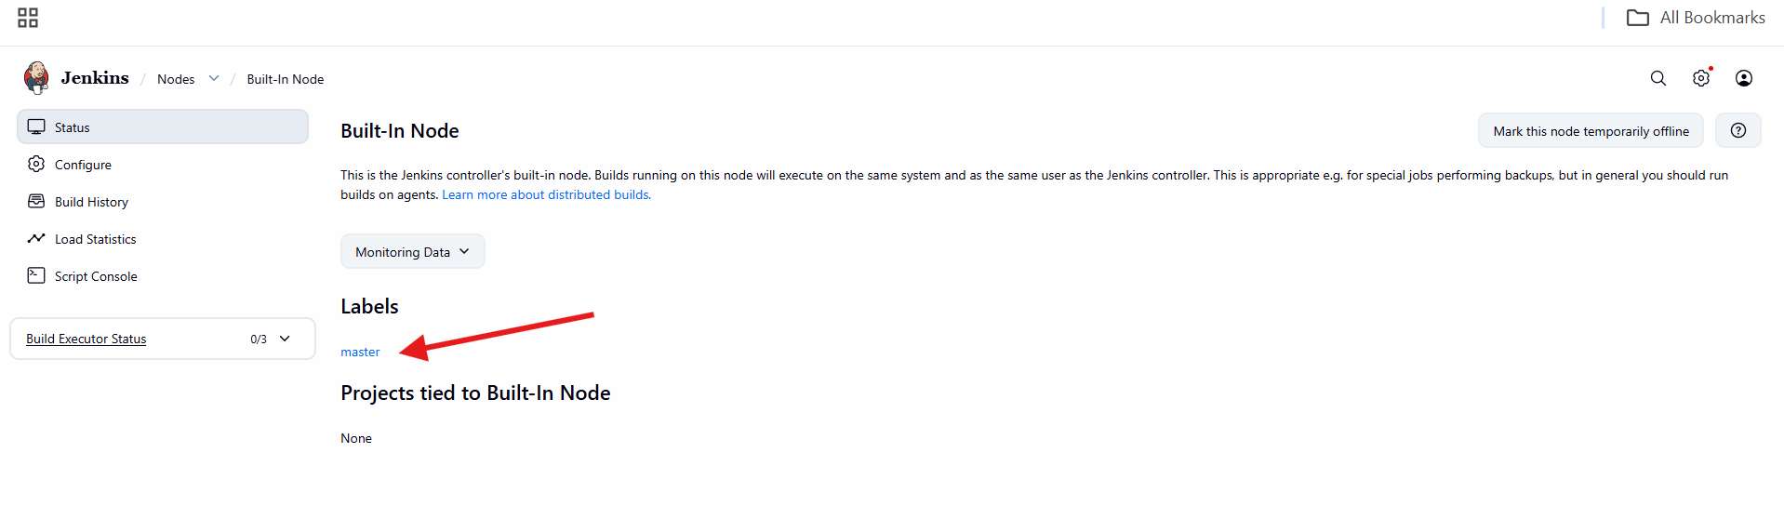

1. Create Three sample jobs using the below URL. <https://github.com/betawins/Techie_horizon_Login_app.git>

**1. Opened Jenkins Dashboard**

* Logged in to Jenkins
* Landed on **Welcome to Jenkins** page

**2. Started Job Creation**

* Clicked **Create a job**
* Navigation:

Dashboard → New Item

**3. Created a Freestyle Job**

* Entered job name:

sample-1

* Selected:

Freestyle project

* Clicked **OK**

**4. Configured Job to Run on Built-In Node**

* Opened:

sample-1 → Configure

* Enabled:

Restrict where this project can be run

* Set **Label Expression**:

master

**5. Configured Source Code Management**

* Selected:

Git

* Entered Repository URL:

https://github.com/betawins/Techie_horizon_login_app.git

* Credentials left as:

None

* Clicked **Save**

**6. Checked Git Availability on Server**

* Logged into EC2 instance
* Checked Git version:

git --version

* Git not found

**7. Installed Git on Jenkins Server**

* Installed Git using YUM

**Command used:**

yum install git -y

**8. Triggered Job Build**

* Opened:

sample-1 → Build Now

* Build started immediately

**9. Verified Build Execution**

* Build appeared in **Build History**
* Build status showed **Success (green tick)**

**10. Viewed Build Details**

* Clicked build number #1
* Opened **Console Output**

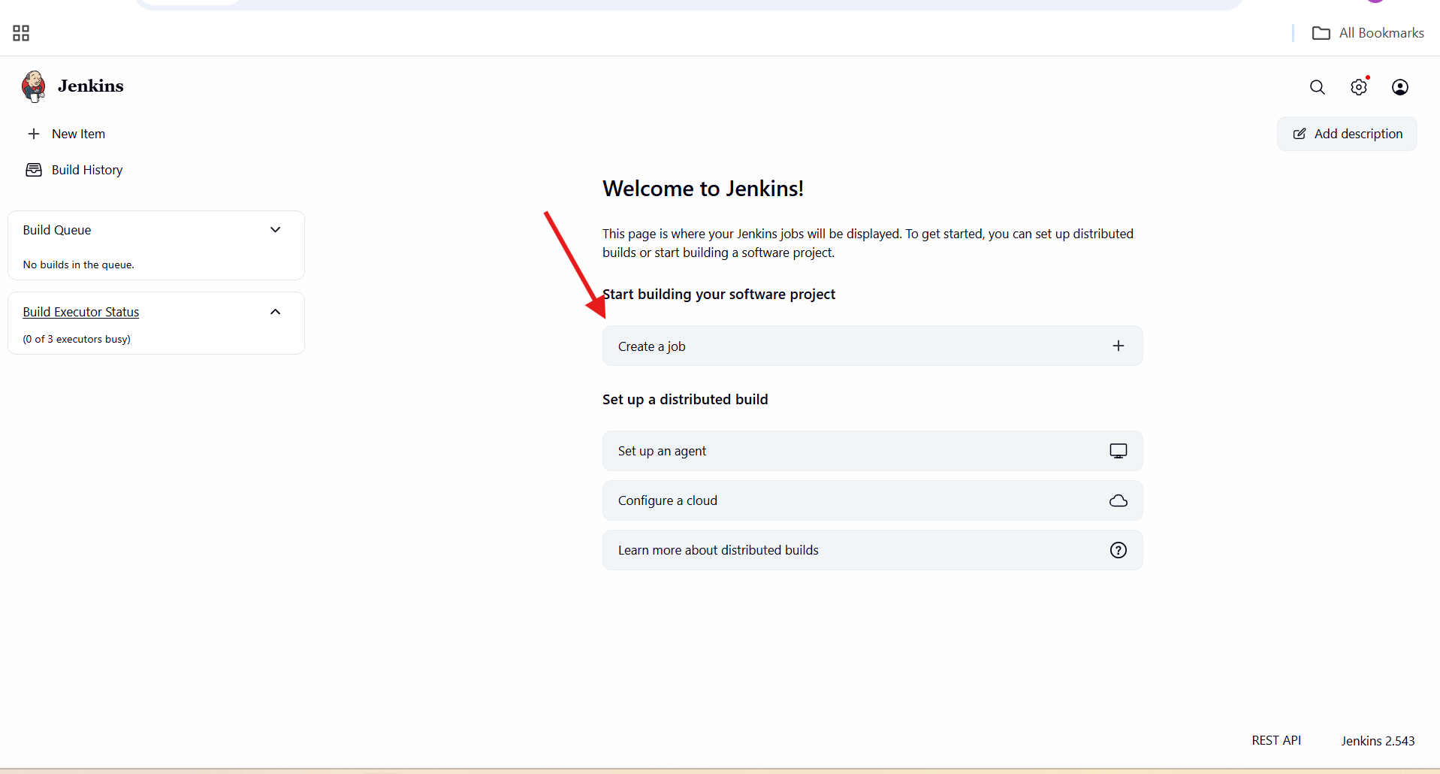

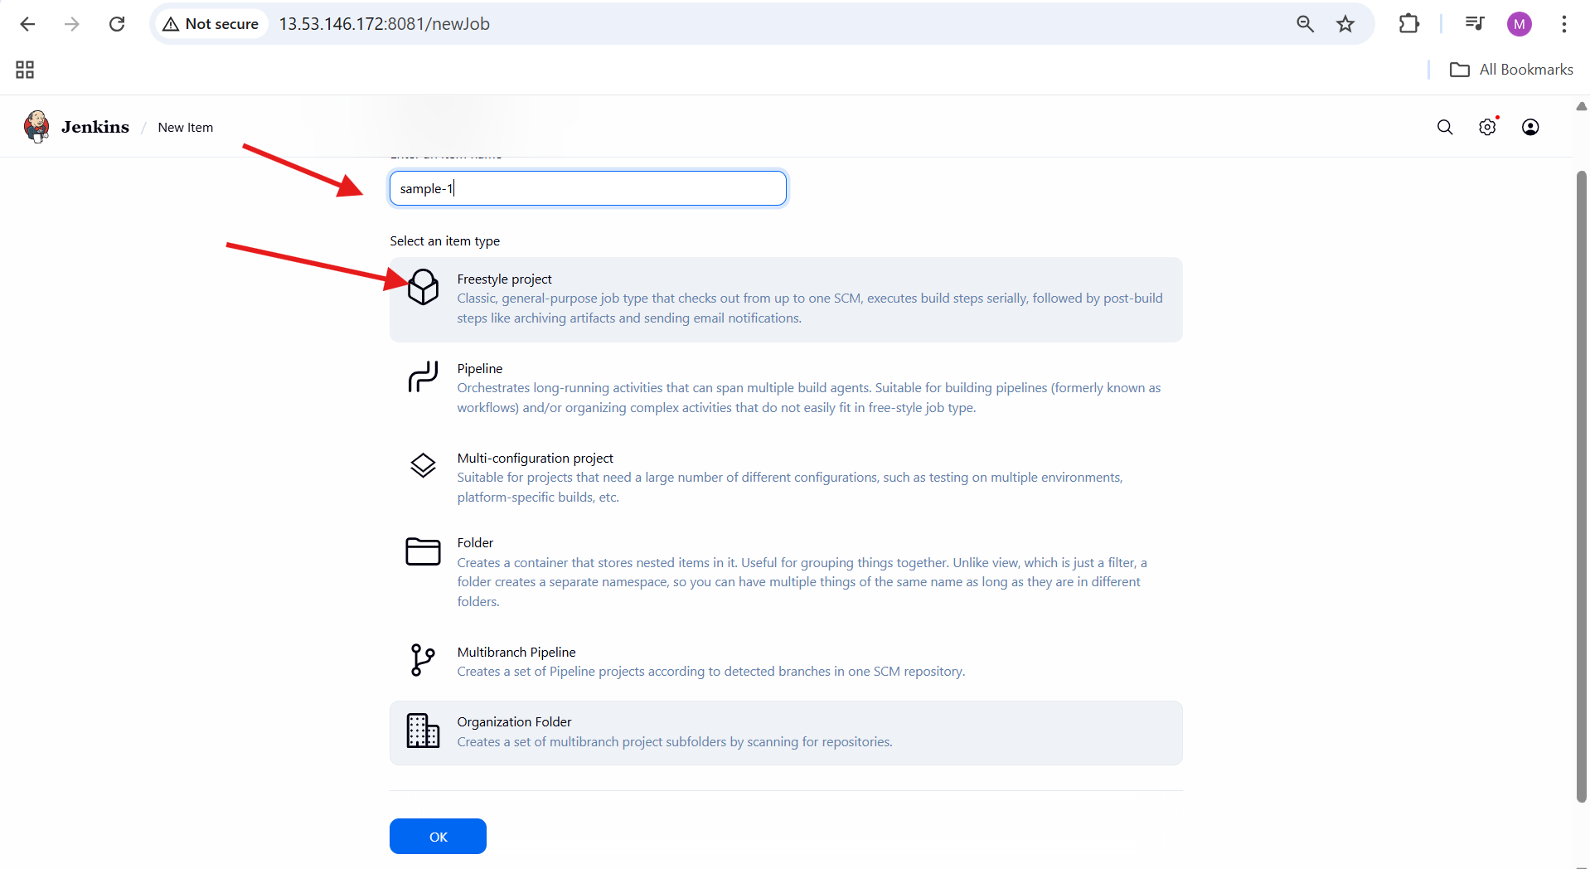

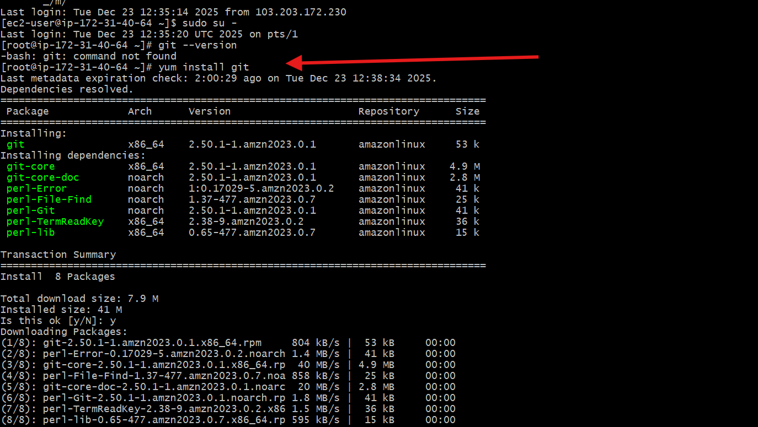

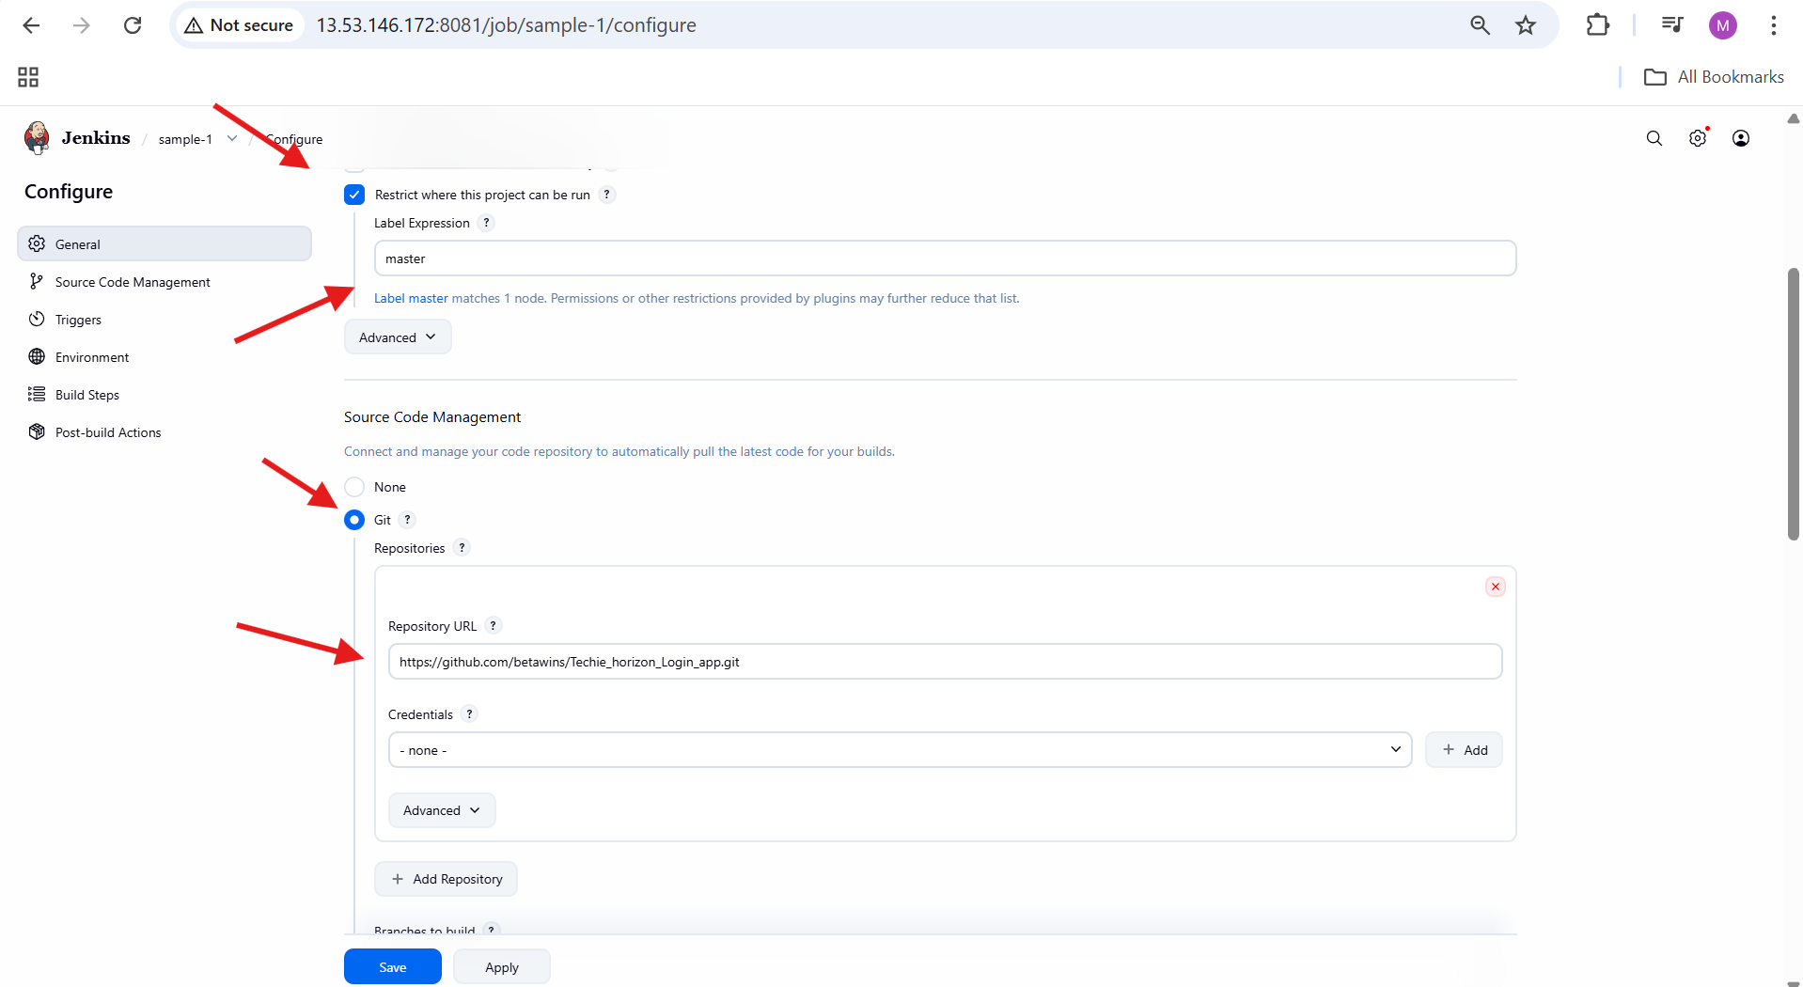

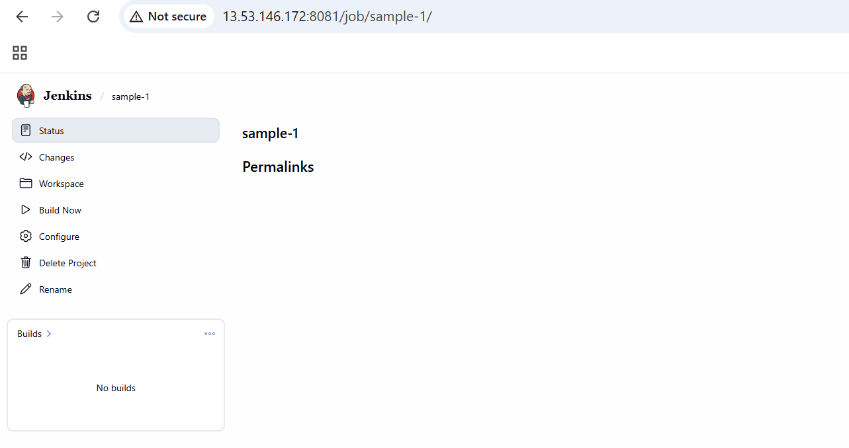

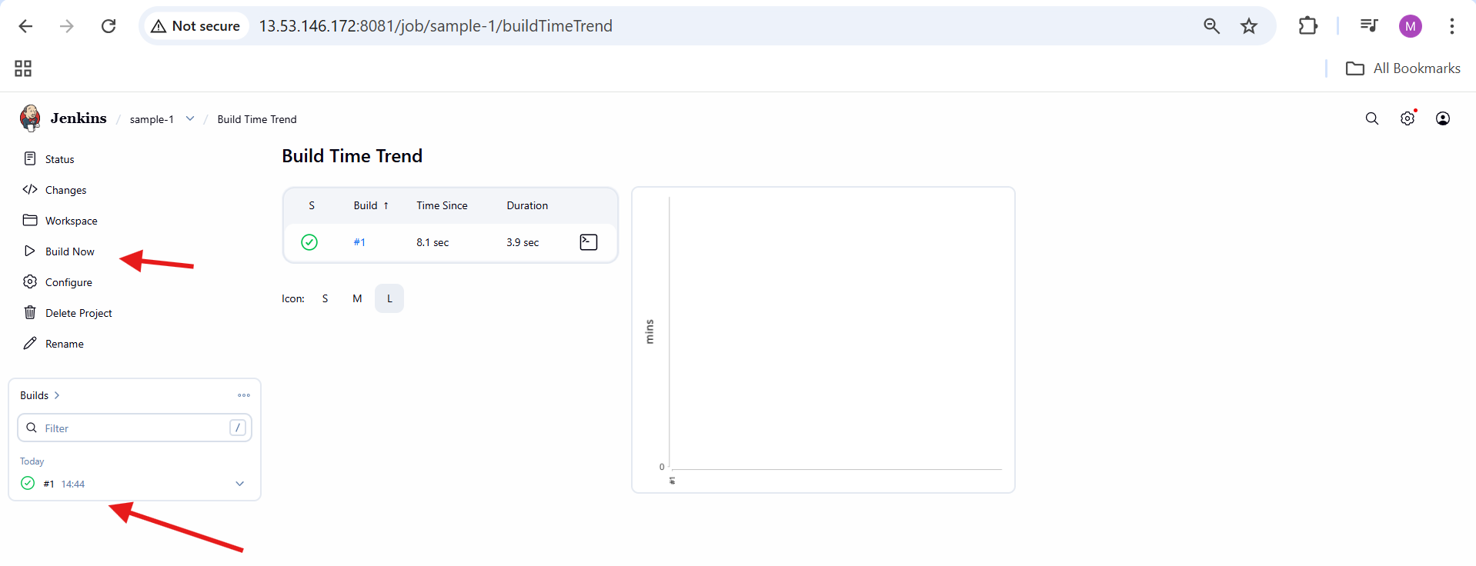

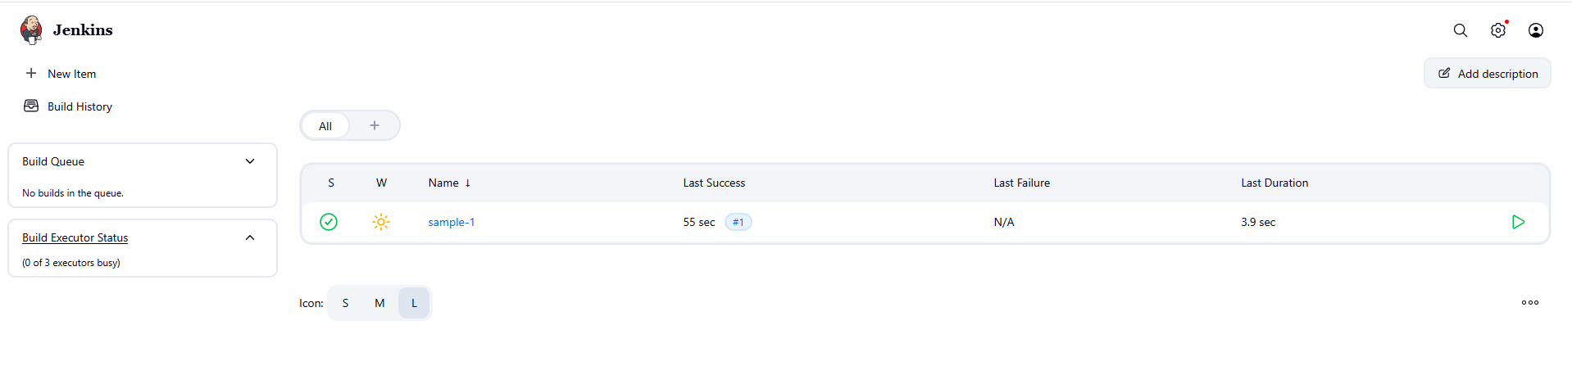

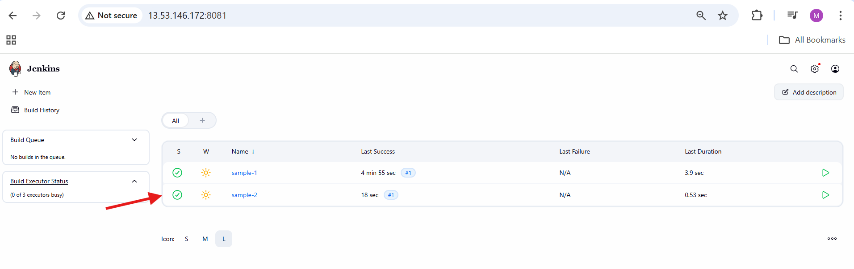

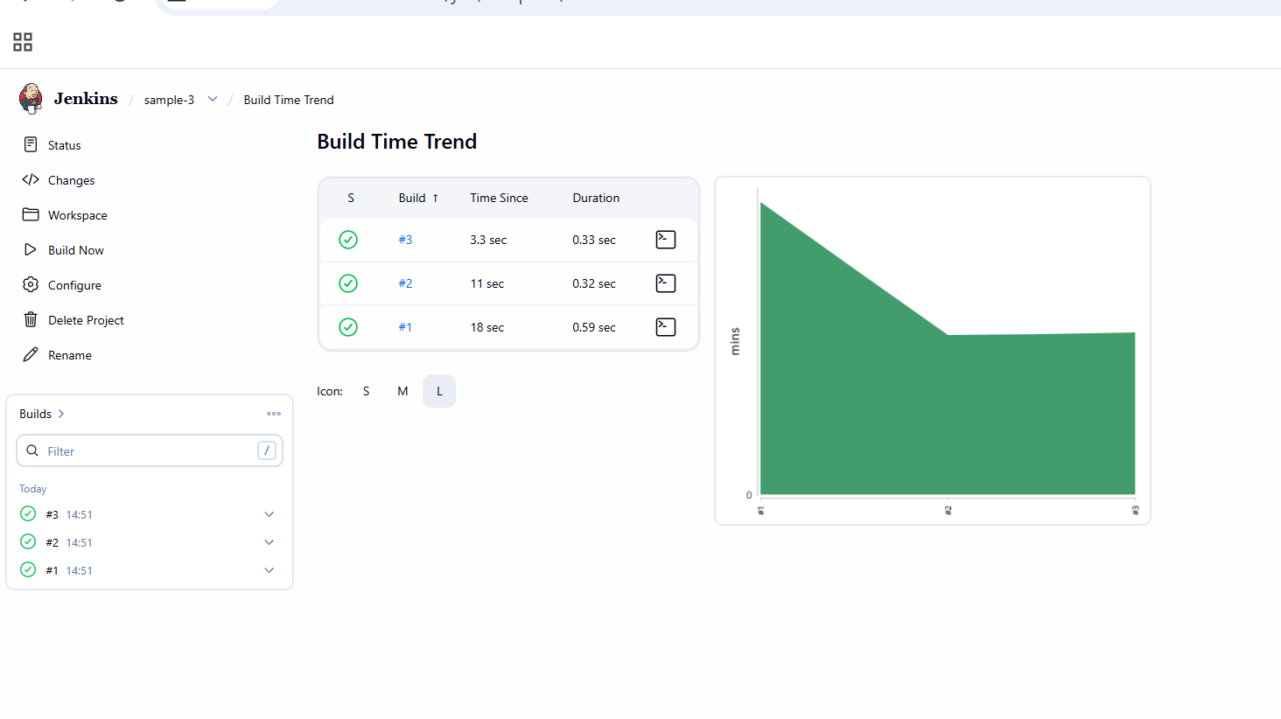

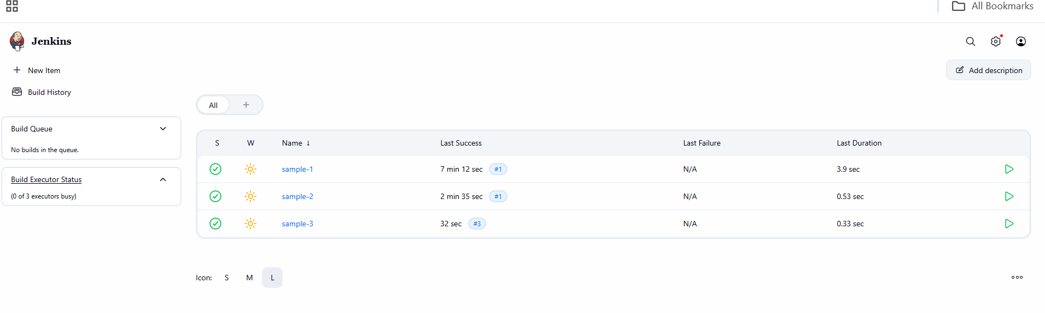

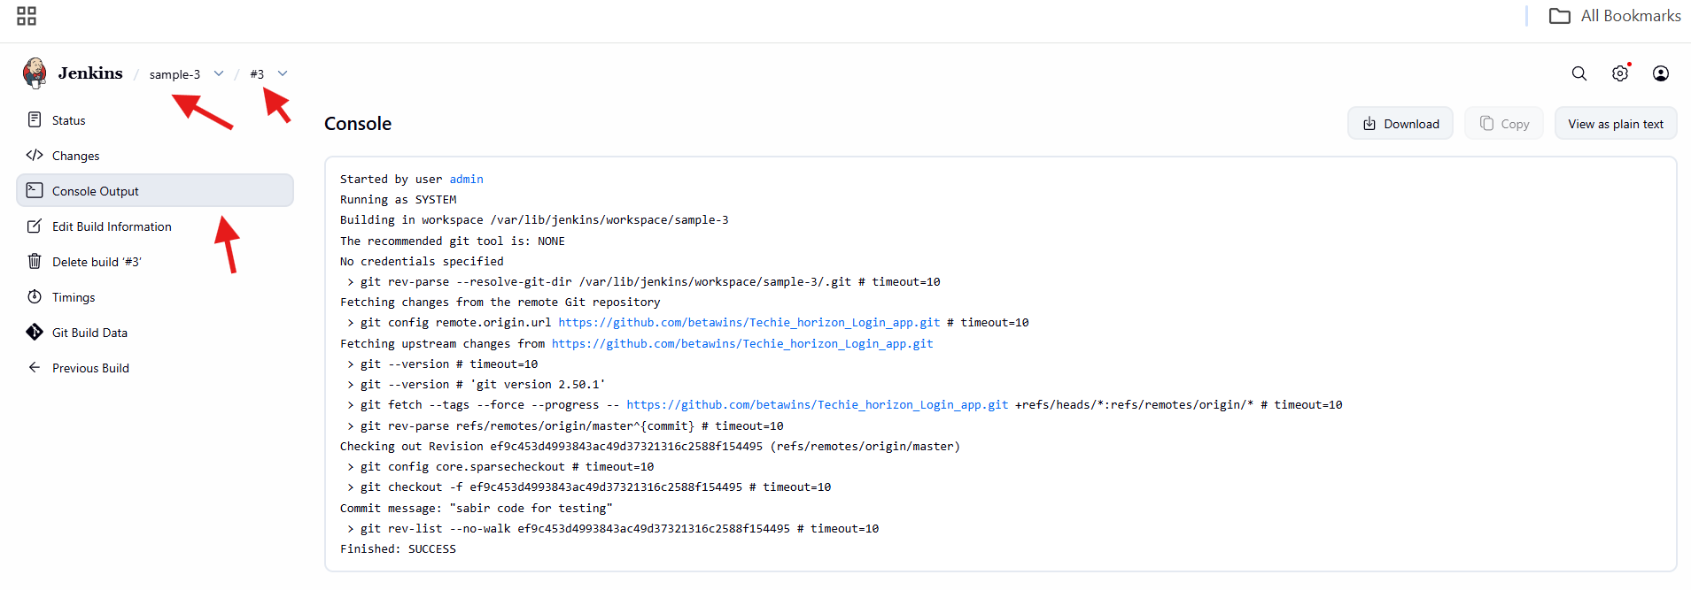

2.Create one Jenkins job using git hub Private repository.

**1. Identified the Repository Is Private**

* Opened GitHub profile → **Repositories**
* Observed repository:

jenkins (Private)

* Understood that **credentials are mandatory** for Jenkins

**2. Configured Jenkins Job for Private Repo**

* Opened Jenkins job:

private-repo → Configure

* Enabled:

Restrict where this project can be run

* Label Expression:

master

**3. Added Git Repository URL**

* In **Source Code Management**
* Selected:

Git

* Entered Repository URL:

https://github.com/mujahed1716/jenkins.git

**4. Faced Authentication Error (Expected)**

Jenkins showed error:

Invalid username or token.

Password authentication is not supported for Git operations.

Authentication failed.

This confirms **GitHub no longer allows password authentication**

**5. Started Adding Jenkins Credentials**

* In **Credentials** dropdown
* Clicked:

Add → Jenkins Credentials Provider

**6. Opened GitHub Developer Settings**

* On GitHub:

Profile → Settings → Developer settings

**7. Navigated to Personal Access Tokens**

* Clicked:

Personal access tokens → Tokens (classic)

**8. Generated New Personal Access Token (Classic)**

* Clicked:

Generate new token → Generate new token (classic)

**9. Configured Token Details**

* **Note**:

jenkins

* **Expiration**:

30 days

* **Scopes selected**:

✔ repo

(Required for private repositories)

**10. Generated and Copied Token**

* Clicked **Generate token**
* Copied the token immediately  
   Token is shown **only once**

**11. Added GitHub Credentials in Jenkins**

In **Add Credentials** popup:

* Kind:

Username with password

* Scope:

Global

* Username:

mujahed1716

* Password:

<PASTE GITHUB PAT HERE>

* Description (optional):

github-private-repo

* Clicked **Add**

**12. Selected Credentials for Repository**

* Back in job configuration
* In **Credentials dropdown**, selected:

mujahed1716/******

**13. Verified Repository Connection**

* Red authentication error disappeared
* Jenkins successfully validated repository
* Clicked **Save**

**14. Observed Failed Build in Job Dashboard**

* Opened:

private-repo → Status

* Noted:
  + Red ❌ icon
  + Build **#1** marked as failed
  + “Last failed build” link highlighted

**16. Opened Failed Build Console Output**

* Clicked:

Build #1 → Console Output

* Error observed:

ERROR: Couldn't find any revision to build.

Verify the repository and branch configuration for this job.

Finished: FAILURe

**17. Identified Exact Root Cause**

* Jenkins authenticated successfully
* Repository cloned correctly
* ❌ Branch not found
* Reason:
  + Repository default branch is **main**
  + Jenkins branch specifier was missing / incorrect

**18. Opened Job Configuration to Fix Branch**

* Navigated to:

private-repo → Configure → Source Code Management

**19. Corrected Branch Specifier**

* In **Branches to build**
* Updated **Branch Specifier** to:

*/main

**20. Saved Updated Job Configuration**

* Clicked **Save**
* Configuration applied successfully

**21. Verified GitHub Repository State**

* Opened GitHub repo:

mujahed1716/jenkins

* Confirmed:
  + Branch: main
  + File present: README.md
  + At least one commit exists

**22. Triggered New Build After Fix**

* Returned to Jenkins job
* Clicked **Build Now**
* New build created (**Build #3**)

**23. Build Completed Successfully**

* Build status changed to **green ✅**
* Build details showed:
  + Branch: refs/remotes/origin/main
  + Commit checked out successfully

**24. Opened Successful Build Details**

* Opened:

private-repo → Build #3

* Observed:
  + Build duration displayed
  + No changes (clean checkout)
  + Repository URL listed

**25. Verified Successful Console Output**

* Clicked:

Build #3 → Console Output

* Key logs:

Checking out Revision (origin/main)

Commit message: Create README.md

Finished: SUCCESS

**26. Confirmed Final Job State**

* Returned to job dashboard
* Observed:
  + Latest build: **SUCCESS**
  + Previous failed build retained for history
  + Job now stable and reusable

